Beam 200
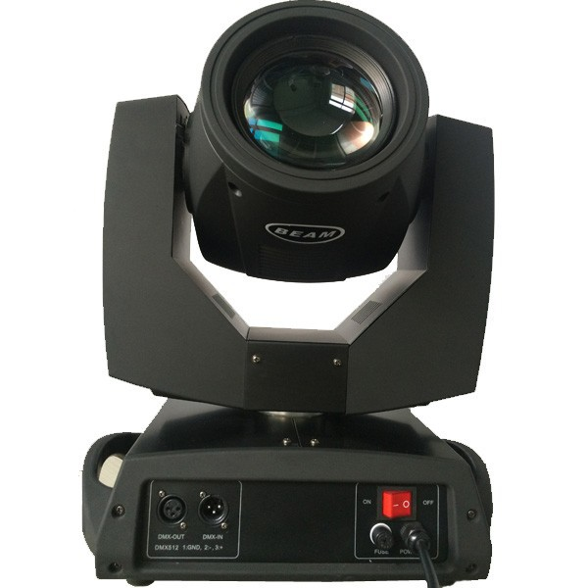 |  | 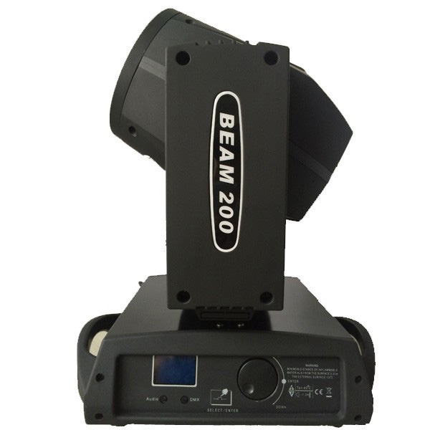
Lamp Type: | Moving Head Lights | Lamp Inside: | MSD 5R
Working Temperature: | 15-45 | Color Temperature: | 8000K
Lamp Power(W): | 200W | Input Voltage(V): | 100-240V
Colour:  Gomo: | 14 Colors + open  17 Gobos + open | Channel Mode: | 16 Channel
Packing Size: | 338*280*480mm | Net Weight: | 16.5kg

