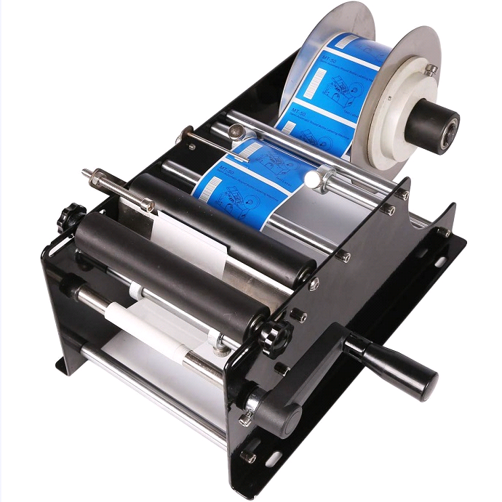

**Model:** DM-MRLM-30

**Speed:** 30 times/min

**Accuracy:** 0.5 mm

**Label Roll inner diameter:** ≥75 mm

**Label Roll Out  diameter:** ≤190 mm

**Bottle diameter:**15-120mm,H≤150 mm

**Label width:**10-110 mm

**Label Length:**10-300 mm

**Machine size:** 400*240*210 mm

**Machine weight:**4.5kg