**Brand:**

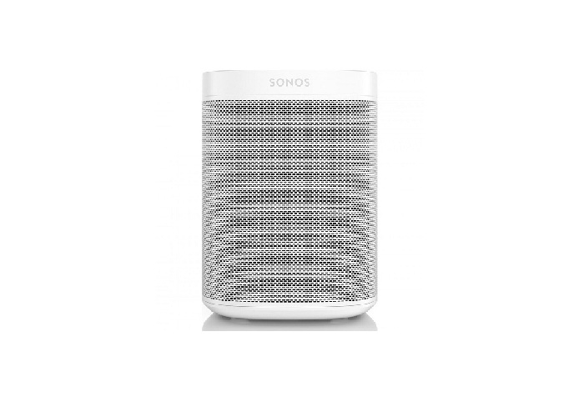Sonos

**Model:**

ONEG1UK1

**Weight in Kg:**

90.0000

**Color:**

Black

**System**

Wireless Stereo and Network

**Output Power**

Auto-switching 100 - 240 VAC, 50/60 Hz universal.

**Frequency**

One tweeter creates a crisp and accurate high frequency response.